Schema MensajeHacienda.xsd

schema location: | D:\Documents\NetBeansProjects\Ministerio de Hacienda\xml-schemas\MensajeHacienda.xsd
attributeFormDefault: | unqualified
elementFormDefault: | qualified
targetNamespace: | https://cdn.comprobanteselectronicos.go.cr/xml-schemas/v4.3/mensajeHacienda

Elements
MensajeHacienda

schema location: | C:\Program Files\Altova\Common2017\Schemas\xmldsig\files\xmldsig-core-schema.xsd
attributeFormDefault:
elementFormDefault: | qualified
targetNamespace: | http://www.w3.org/2000/09/xmldsig#

Elements | Complex types | Simple types
CanonicalizationMethod | CanonicalizationMethodType | CryptoBinary
DigestMethod | DigestMethodType | DigestValueType
DigestValue | DSAKeyValueType | HMACOutputLengthType
DSAKeyValue | KeyInfoType
KeyInfo | KeyValueType
KeyName | ManifestType
KeyValue | ObjectType
Manifest | PGPDataType
MgmtData | ReferenceType
Object | RetrievalMethodType
PGPData | RSAKeyValueType
Reference | SignatureMethodType
RetrievalMethod | SignaturePropertiesType
RSAKeyValue | SignaturePropertyType
Signature | SignatureType
SignatureMethod | SignatureValueType
SignatureProperties | SignedInfoType
SignatureProperty | SPKIDataType
SignatureValue | TransformsType
SignedInfo | TransformType
SPKIData | X509DataType
Transform | X509IssuerSerialType
Transforms
X509Data

element MensajeHacienda
diagram | 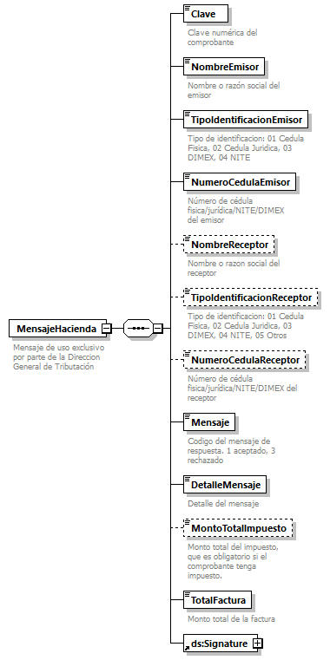
namespace | https://cdn.comprobanteselectronicos.go.cr/xml-schemas/v4.3/mensajeHacienda
properties
  content | complex
children | Clave NombreEmisor TipoIdentificacionEmisor NumeroCedulaEmisor NombreReceptor TipoIdentificacionReceptor NumeroCedulaReceptor Mensaje DetalleMensaje MontoTotalImpuesto TotalFactura ds:Signature
annotation
  documentation
  Mensaje de uso exclusivo por parte de la Direccion General de Tributación
source | <xs:element name="MensajeHacienda">  <xs:annotation>  <xs:documentation>Mensaje de uso exclusivo por parte de la Direccion General de Tributación</xs:documentation>  </xs:annotation>  <xs:complexType>  <xs:sequence>  <xs:element name="Clave">  <xs:annotation>  <xs:documentation>Clave numérica del comprobante</xs:documentation>  </xs:annotation>  <xs:simpleType>  <xs:restriction base="xs:string">  <xs:pattern value="\d{50,50}"/>  </xs:restriction>  </xs:simpleType>  </xs:element>  <xs:element name="NombreEmisor">  <xs:annotation>  <xs:documentation>Nombre o razón social del emisor</xs:documentation>  </xs:annotation>  <xs:simpleType>  <xs:restriction base="xs:string">  <xs:maxLength value="100"/>  </xs:restriction>  </xs:simpleType>  </xs:element>  <xs:element name="TipoIdentificacionEmisor" nillable="false">  <xs:annotation>  <xs:documentation>Tipo de identificacion: 01 Cedula Fisica, 02 Cedula Juridica, 03 DIMEX, 04 NITE</xs:documentation>  </xs:annotation>  <xs:simpleType>  <xs:restriction base="xs:string">  <xs:enumeration value="01">  <xs:annotation>  <xs:documentation>Cedula Fisica</xs:documentation>  </xs:annotation>  </xs:enumeration>  <xs:enumeration value="02">  <xs:annotation>  <xs:documentation> Cedula Juridica</xs:documentation>  </xs:annotation>  </xs:enumeration>  <xs:enumeration value="03">  <xs:annotation>  <xs:documentation>DIMEX</xs:documentation>  </xs:annotation>  </xs:enumeration>  <xs:enumeration value="04">  <xs:annotation>  <xs:documentation>NITE</xs:documentation>  </xs:annotation>  </xs:enumeration>  </xs:restriction>  </xs:simpleType>  </xs:element>  <xs:element name="NumeroCedulaEmisor">  <xs:annotation>  <xs:documentation>Número de cédula fisica/jurídica/NITE/DIMEX del emisor</xs:documentation>  </xs:annotation>  <xs:simpleType>  <xs:restriction base="xs:string">  <xs:maxLength value="12"/>  <xs:pattern value="\d{9,12}"/>  </xs:restriction>  </xs:simpleType>  </xs:element>  <xs:element name="NombreReceptor" nillable="false" minOccurs="0">  <xs:annotation>  <xs:documentation>Nombre o razon social del receptor</xs:documentation>  </xs:annotation>  <xs:simpleType>  <xs:restriction base="xs:string">  <xs:maxLength value="100"/>  <xs:minLength value="0"/>  </xs:restriction>  </xs:simpleType>  </xs:element>  <xs:element name="TipoIdentificacionReceptor" nillable="true" minOccurs="0">  <xs:annotation>  <xs:documentation>Tipo de identificacion: 01 Cedula Fisica, 02 Cedula Juridica, 03 DIMEX, 04 NITE, 05 Otros</xs:documentation>  </xs:annotation>  <xs:simpleType>  <xs:restriction base="xs:string">  <xs:enumeration value="01">  <xs:annotation>  <xs:documentation>Cedula Fisica</xs:documentation>  </xs:annotation>  </xs:enumeration>  <xs:enumeration value="02">  <xs:annotation>  <xs:documentation> Cedula Juridica</xs:documentation>  </xs:annotation>  </xs:enumeration>  <xs:enumeration value="03">  <xs:annotation>  <xs:documentation>DIMEX</xs:documentation>  </xs:annotation>  </xs:enumeration>  <xs:enumeration value="04">  <xs:annotation>  <xs:documentation>NITE</xs:documentation>  </xs:annotation>  </xs:enumeration>  <xs:enumeration value="05">  <xs:annotation>  <xs:documentation>Otros</xs:documentation>  </xs:annotation>  </xs:enumeration>  </xs:restriction>  </xs:simpleType>  </xs:element>  <xs:element name="NumeroCedulaReceptor" nillable="true" minOccurs="0">  <xs:annotation>  <xs:documentation>Número de cédula fisica/jurídica/NITE/DIMEX del receptor</xs:documentation>  </xs:annotation>  <xs:simpleType>  <xs:restriction base="xs:string">  <xs:maxLength value="12"/>  <xs:pattern value="\d{9,12}"/>  </xs:restriction>  </xs:simpleType>  </xs:element>  <xs:element name="Mensaje">  <xs:annotation>  <xs:documentation>Codigo del mensaje de respuesta. 1 aceptado, 3 rechazado</xs:documentation>  </xs:annotation>  <xs:simpleType>  <xs:restriction base="xs:integer">  <xs:enumeration value="1">  <xs:annotation>  <xs:documentation>Aceptado</xs:documentation>  </xs:annotation>  </xs:enumeration>  <xs:enumeration value="3">  <xs:annotation>  <xs:documentation>Rechazado</xs:documentation>  </xs:annotation>  </xs:enumeration>  </xs:restriction>  </xs:simpleType>  </xs:element>  <xs:element name="DetalleMensaje">  <xs:annotation>  <xs:documentation>Detalle del mensaje</xs:documentation>  </xs:annotation>  <xs:simpleType>  <xs:restriction base="xs:string"/>  </xs:simpleType>  </xs:element>  <xs:element name="MontoTotalImpuesto" minOccurs="0">  <xs:annotation>  <xs:documentation>Monto total del impuesto, que es obligatorio si el comprobante tenga impuesto.</xs:documentation>  </xs:annotation>  <xs:simpleType>  <xs:restriction base="xs:decimal">  <xs:totalDigits value="18"/>  <xs:fractionDigits value="5"/>  </xs:restriction>  </xs:simpleType>  </xs:element>  <xs:element name="TotalFactura">  <xs:annotation>  <xs:documentation>Monto total de la factura</xs:documentation>  </xs:annotation>  <xs:simpleType>  <xs:restriction base="xs:decimal">  <xs:totalDigits value="18"/>  <xs:fractionDigits value="5"/>  </xs:restriction>  </xs:simpleType>  </xs:element>  <xs:element ref="ds:Signature" minOccurs="1" maxOccurs="1"/>  </xs:sequence>  </xs:complexType>  </xs:element>

element MensajeHacienda/Clave
diagram | 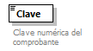
namespace | https://cdn.comprobanteselectronicos.go.cr/xml-schemas/v4.3/mensajeHacienda
type | restriction of xs:string
properties
  content | simple
facets
  Kind | Value | Annotation
  pattern | \d{50,50}
annotation
  documentation
  Clave numérica del comprobante
source | <xs:element name="Clave">  <xs:annotation>  <xs:documentation>Clave numérica del comprobante</xs:documentation>  </xs:annotation>  <xs:simpleType>  <xs:restriction base="xs:string">  <xs:pattern value="\d{50,50}"/>  </xs:restriction>  </xs:simpleType>  </xs:element>

element MensajeHacienda/NombreEmisor
diagram | 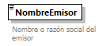
namespace | https://cdn.comprobanteselectronicos.go.cr/xml-schemas/v4.3/mensajeHacienda
type | restriction of xs:string
properties
  content | simple
facets
  Kind | Value | Annotation
  maxLength | 100
annotation
  documentation
  Nombre o razón social del emisor
source | <xs:element name="NombreEmisor">  <xs:annotation>  <xs:documentation>Nombre o razón social del emisor</xs:documentation>  </xs:annotation>  <xs:simpleType>  <xs:restriction base="xs:string">  <xs:maxLength value="100"/>  </xs:restriction>  </xs:simpleType>  </xs:element>

element MensajeHacienda/TipoIdentificacionEmisor
diagram | 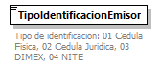
namespace | https://cdn.comprobanteselectronicos.go.cr/xml-schemas/v4.3/mensajeHacienda
type | restriction of xs:string
properties
  content | simple
  nillable | false
facets
  Kind | Value | Annotation
  enumeration | 01
    documentation
    Cedula Fisica
  enumeration | 02
    documentation
    Cedula Juridica
  enumeration | 03
    documentation
    DIMEX
  enumeration | 04
    documentation
    NITE
annotation
  documentation
  Tipo de identificacion: 01 Cedula Fisica, 02 Cedula Juridica, 03 DIMEX, 04 NITE
source | <xs:element name="TipoIdentificacionEmisor" nillable="false">  <xs:annotation>  <xs:documentation>Tipo de identificacion: 01 Cedula Fisica, 02 Cedula Juridica, 03 DIMEX, 04 NITE</xs:documentation>  </xs:annotation>  <xs:simpleType>  <xs:restriction base="xs:string">  <xs:enumeration value="01">  <xs:annotation>  <xs:documentation>Cedula Fisica</xs:documentation>  </xs:annotation>  </xs:enumeration>  <xs:enumeration value="02">  <xs:annotation>  <xs:documentation> Cedula Juridica</xs:documentation>  </xs:annotation>  </xs:enumeration>  <xs:enumeration value="03">  <xs:annotation>  <xs:documentation>DIMEX</xs:documentation>  </xs:annotation>  </xs:enumeration>  <xs:enumeration value="04">  <xs:annotation>  <xs:documentation>NITE</xs:documentation>  </xs:annotation>  </xs:enumeration>  </xs:restriction>  </xs:simpleType>  </xs:element>

element MensajeHacienda/NumeroCedulaEmisor
diagram | 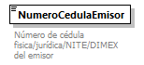
namespace | https://cdn.comprobanteselectronicos.go.cr/xml-schemas/v4.3/mensajeHacienda
type | restriction of xs:string
properties
  content | simple
facets
  Kind | Value | Annotation
  maxLength | 12
  pattern | \d{9,12}
annotation
  documentation
  Número de cédula fisica/jurídica/NITE/DIMEX del emisor
source | <xs:element name="NumeroCedulaEmisor">  <xs:annotation>  <xs:documentation>Número de cédula fisica/jurídica/NITE/DIMEX del emisor</xs:documentation>  </xs:annotation>  <xs:simpleType>  <xs:restriction base="xs:string">  <xs:maxLength value="12"/>  <xs:pattern value="\d{9,12}"/>  </xs:restriction>  </xs:simpleType>  </xs:element>

element MensajeHacienda/NombreReceptor
diagram | 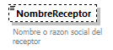
namespace | https://cdn.comprobanteselectronicos.go.cr/xml-schemas/v4.3/mensajeHacienda
type | restriction of xs:string
properties
  minOcc | 0
  maxOcc | 1
  content | simple
  nillable | false
facets
  Kind | Value | Annotation
  minLength | 0
  maxLength | 100
annotation
  documentation
  Nombre o razon social del receptor
source | <xs:element name="NombreReceptor" nillable="false" minOccurs="0">  <xs:annotation>  <xs:documentation>Nombre o razon social del receptor</xs:documentation>  </xs:annotation>  <xs:simpleType>  <xs:restriction base="xs:string">  <xs:maxLength value="100"/>  <xs:minLength value="0"/>  </xs:restriction>  </xs:simpleType>  </xs:element>

element MensajeHacienda/TipoIdentificacionReceptor
diagram | 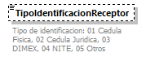
namespace | https://cdn.comprobanteselectronicos.go.cr/xml-schemas/v4.3/mensajeHacienda
type | restriction of xs:string
properties
  minOcc | 0
  maxOcc | 1
  content | simple
  nillable | true
facets
  Kind | Value | Annotation
  enumeration | 01
    documentation
    Cedula Fisica
  enumeration | 02
    documentation
    Cedula Juridica
  enumeration | 03
    documentation
    DIMEX
  enumeration | 04
    documentation
    NITE
  enumeration | 05
    documentation
    Otros
annotation
  documentation
  Tipo de identificacion: 01 Cedula Fisica, 02 Cedula Juridica, 03 DIMEX, 04 NITE, 05 Otros
source | <xs:element name="TipoIdentificacionReceptor" nillable="true" minOccurs="0">  <xs:annotation>  <xs:documentation>Tipo de identificacion: 01 Cedula Fisica, 02 Cedula Juridica, 03 DIMEX, 04 NITE, 05 Otros</xs:documentation>  </xs:annotation>  <xs:simpleType>  <xs:restriction base="xs:string">  <xs:enumeration value="01">  <xs:annotation>  <xs:documentation>Cedula Fisica</xs:documentation>  </xs:annotation>  </xs:enumeration>  <xs:enumeration value="02">  <xs:annotation>  <xs:documentation> Cedula Juridica</xs:documentation>  </xs:annotation>  </xs:enumeration>  <xs:enumeration value="03">  <xs:annotation>  <xs:documentation>DIMEX</xs:documentation>  </xs:annotation>  </xs:enumeration>  <xs:enumeration value="04">  <xs:annotation>  <xs:documentation>NITE</xs:documentation>  </xs:annotation>  </xs:enumeration>  <xs:enumeration value="05">  <xs:annotation>  <xs:documentation>Otros</xs:documentation>  </xs:annotation>  </xs:enumeration>  </xs:restriction>  </xs:simpleType>  </xs:element>

element MensajeHacienda/NumeroCedulaReceptor
diagram | 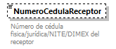
namespace | https://cdn.comprobanteselectronicos.go.cr/xml-schemas/v4.3/mensajeHacienda
type | restriction of xs:string
properties
  minOcc | 0
  maxOcc | 1
  content | simple
  nillable | true
facets
  Kind | Value | Annotation
  maxLength | 12
  pattern | \d{9,12}
annotation
  documentation
  Número de cédula fisica/jurídica/NITE/DIMEX del receptor
source | <xs:element name="NumeroCedulaReceptor" nillable="true" minOccurs="0">  <xs:annotation>  <xs:documentation>Número de cédula fisica/jurídica/NITE/DIMEX del receptor</xs:documentation>  </xs:annotation>  <xs:simpleType>  <xs:restriction base="xs:string">  <xs:maxLength value="12"/>  <xs:pattern value="\d{9,12}"/>  </xs:restriction>  </xs:simpleType>  </xs:element>

element MensajeHacienda/Mensaje
diagram | 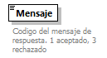
namespace | https://cdn.comprobanteselectronicos.go.cr/xml-schemas/v4.3/mensajeHacienda
type | restriction of xs:integer
properties
  content | simple
facets
  Kind | Value | Annotation
  enumeration | 1
    documentation
    Aceptado
  enumeration | 3
    documentation
    Rechazado
annotation
  documentation
  Codigo del mensaje de respuesta. 1 aceptado, 3 rechazado
source | <xs:element name="Mensaje">  <xs:annotation>  <xs:documentation>Codigo del mensaje de respuesta. 1 aceptado, 3 rechazado</xs:documentation>  </xs:annotation>  <xs:simpleType>  <xs:restriction base="xs:integer">  <xs:enumeration value="1">  <xs:annotation>  <xs:documentation>Aceptado</xs:documentation>  </xs:annotation>  </xs:enumeration>  <xs:enumeration value="3">  <xs:annotation>  <xs:documentation>Rechazado</xs:documentation>  </xs:annotation>  </xs:enumeration>  </xs:restriction>  </xs:simpleType>  </xs:element>

element MensajeHacienda/DetalleMensaje
diagram | 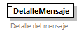
namespace | https://cdn.comprobanteselectronicos.go.cr/xml-schemas/v4.3/mensajeHacienda
type | restriction of xs:string
properties
  content | simple
annotation
  documentation
  Detalle del mensaje
source | <xs:element name="DetalleMensaje">  <xs:annotation>  <xs:documentation>Detalle del mensaje</xs:documentation>  </xs:annotation>  <xs:simpleType>  <xs:restriction base="xs:string"/>  </xs:simpleType>  </xs:element>

element MensajeHacienda/MontoTotalImpuesto
diagram | 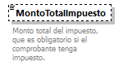
namespace | https://cdn.comprobanteselectronicos.go.cr/xml-schemas/v4.3/mensajeHacienda
type | restriction of xs:decimal
properties
  minOcc | 0
  maxOcc | 1
  content | simple
facets
  Kind | Value | Annotation
  totalDigits | 18
  fractionDigits | 5
annotation
  documentation
  Monto total del impuesto, que es obligatorio si el comprobante tenga impuesto.
source | <xs:element name="MontoTotalImpuesto" minOccurs="0">  <xs:annotation>  <xs:documentation>Monto total del impuesto, que es obligatorio si el comprobante tenga impuesto.</xs:documentation>  </xs:annotation>  <xs:simpleType>  <xs:restriction base="xs:decimal">  <xs:totalDigits value="18"/>  <xs:fractionDigits value="5"/>  </xs:restriction>  </xs:simpleType>  </xs:element>

element MensajeHacienda/TotalFactura
diagram | 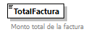
namespace | https://cdn.comprobanteselectronicos.go.cr/xml-schemas/v4.3/mensajeHacienda
type | restriction of xs:decimal
properties
  content | simple
facets
  Kind | Value | Annotation
  totalDigits | 18
  fractionDigits | 5
annotation
  documentation
  Monto total de la factura
source | <xs:element name="TotalFactura">  <xs:annotation>  <xs:documentation>Monto total de la factura</xs:documentation>  </xs:annotation>  <xs:simpleType>  <xs:restriction base="xs:decimal">  <xs:totalDigits value="18"/>  <xs:fractionDigits value="5"/>  </xs:restriction>  </xs:simpleType>  </xs:element>

element CanonicalizationMethod
diagram | 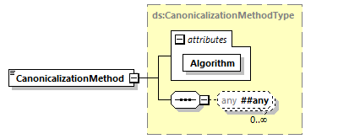
namespace | http://www.w3.org/2000/09/xmldsig#
type | ds:CanonicalizationMethodType
properties
  content | complex
  mixed | true
used by
  complexType | SignedInfoType
attributes
  Name | Type | Use | Default | Fixed | Annotation
  Algorithm | xs:anyURI | required
source | <xs:element name="CanonicalizationMethod" type="ds:CanonicalizationMethodType"/>

element DigestMethod
diagram | 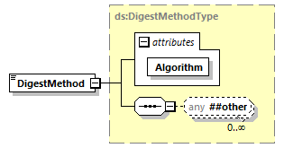
namespace | http://www.w3.org/2000/09/xmldsig#
type | ds:DigestMethodType
properties
  content | complex
  mixed | true
used by
  complexType | ReferenceType
attributes
  Name | Type | Use | Default | Fixed | Annotation
  Algorithm | xs:anyURI | required
source | <xs:element name="DigestMethod" type="ds:DigestMethodType"/>

element DigestValue
diagram | 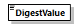
namespace | http://www.w3.org/2000/09/xmldsig#
type | ds:DigestValueType
properties
  content | simple
used by
  complexType | ReferenceType
source | <xs:element name="DigestValue" type="ds:DigestValueType"/>

element DSAKeyValue
diagram | 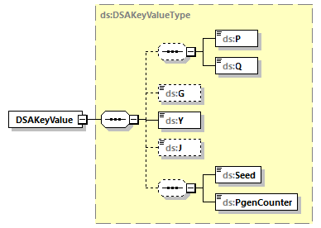
namespace | http://www.w3.org/2000/09/xmldsig#
type | ds:DSAKeyValueType
properties
  content | complex
children | ds:P ds:Q ds:G ds:Y ds:J ds:Seed ds:PgenCounter
used by
  complexType | KeyValueType
source | <xs:element name="DSAKeyValue" type="ds:DSAKeyValueType"/>

element KeyInfo
diagram | 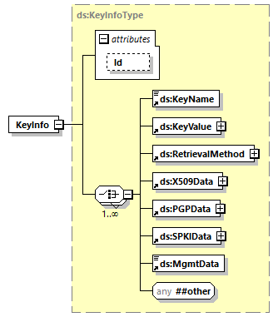
namespace | http://www.w3.org/2000/09/xmldsig#
type | ds:KeyInfoType
properties
  content | complex
  mixed | true
children | ds:KeyName ds:KeyValue ds:RetrievalMethod ds:X509Data ds:PGPData ds:SPKIData ds:MgmtData
used by
  complexType | SignatureType
attributes
  Name | Type | Use | Default | Fixed | Annotation
  Id | xs:ID | optional
source | <xs:element name="KeyInfo" type="ds:KeyInfoType"/>

element KeyName
diagram | 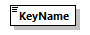
namespace | http://www.w3.org/2000/09/xmldsig#
type | xs:string
properties
  content | simple
used by
  complexType | KeyInfoType
source | <xs:element name="KeyName" type="string"/>

element KeyValue
diagram | 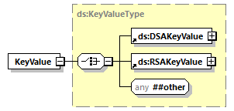
namespace | http://www.w3.org/2000/09/xmldsig#
type | ds:KeyValueType
properties
  content | complex
  mixed | true
children | ds:DSAKeyValue ds:RSAKeyValue
used by
  complexType | KeyInfoType
source | <xs:element name="KeyValue" type="ds:KeyValueType"/>

element Manifest
diagram | 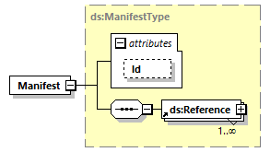
namespace | http://www.w3.org/2000/09/xmldsig#
type | ds:ManifestType
properties
  content | complex
children | ds:Reference
attributes
  Name | Type | Use | Default | Fixed | Annotation
  Id | xs:ID | optional
source | <xs:element name="Manifest" type="ds:ManifestType"/>

element MgmtData
diagram | 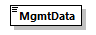
namespace | http://www.w3.org/2000/09/xmldsig#
type | xs:string
properties
  content | simple
used by
  complexType | KeyInfoType
source | <xs:element name="MgmtData" type="string"/>

element Object
diagram | 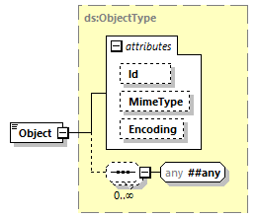
namespace | http://www.w3.org/2000/09/xmldsig#
type | ds:ObjectType
properties
  content | complex
  mixed | true
used by
  complexType | SignatureType
attributes
  Name | Type | Use | Default | Fixed | Annotation
  Id | xs:ID | optional
  MimeType | xs:string | optional
  Encoding | xs:anyURI | optional
source | <xs:element name="Object" type="ds:ObjectType"/>

element PGPData
diagram | 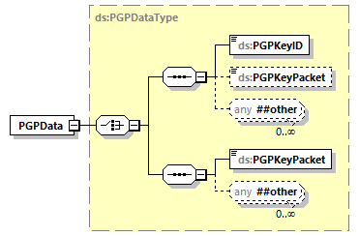
namespace | http://www.w3.org/2000/09/xmldsig#
type | ds:PGPDataType
properties
  content | complex
children | ds:PGPKeyID ds:PGPKeyPacket ds:PGPKeyPacket
used by
  complexType | KeyInfoType
source | <xs:element name="PGPData" type="ds:PGPDataType"/>

element Reference
diagram | 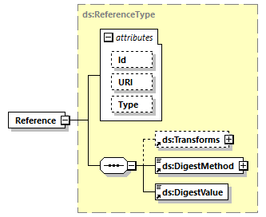
namespace | http://www.w3.org/2000/09/xmldsig#
type | ds:ReferenceType
properties
  content | complex
children | ds:Transforms ds:DigestMethod ds:DigestValue
used by
  complexTypes | ManifestType SignedInfoType
attributes
  Name | Type | Use | Default | Fixed | Annotation
  Id | xs:ID | optional
  URI | xs:anyURI | optional
  Type | xs:anyURI | optional
source | <xs:element name="Reference" type="ds:ReferenceType"/>

element RetrievalMethod
diagram | 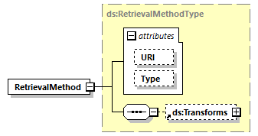
namespace | http://www.w3.org/2000/09/xmldsig#
type | ds:RetrievalMethodType
properties
  content | complex
children | ds:Transforms
used by
  complexType | KeyInfoType
attributes
  Name | Type | Use | Default | Fixed | Annotation
  URI | xs:anyURI
  Type | xs:anyURI | optional
source | <xs:element name="RetrievalMethod" type="ds:RetrievalMethodType"/>

element RSAKeyValue
diagram | 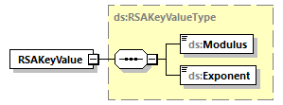
namespace | http://www.w3.org/2000/09/xmldsig#
type | ds:RSAKeyValueType
properties
  content | complex
children | ds:Modulus ds:Exponent
used by
  complexType | KeyValueType
source | <xs:element name="RSAKeyValue" type="ds:RSAKeyValueType"/>

element Signature
diagram | 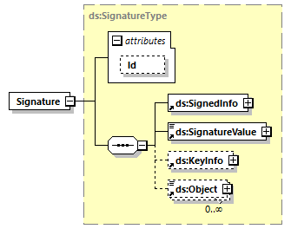
namespace | http://www.w3.org/2000/09/xmldsig#
type | ds:SignatureType
properties
  content | complex
children | ds:SignedInfo ds:SignatureValue ds:KeyInfo ds:Object
used by
  element | MensajeHacienda
attributes
  Name | Type | Use | Default | Fixed | Annotation
  Id | xs:ID | optional
source | <xs:element name="Signature" type="ds:SignatureType"/>

element SignatureMethod
diagram | 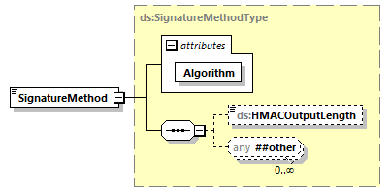
namespace | http://www.w3.org/2000/09/xmldsig#
type | ds:SignatureMethodType
properties
  content | complex
  mixed | true
children | ds:HMACOutputLength
used by
  complexType | SignedInfoType
attributes
  Name | Type | Use | Default | Fixed | Annotation
  Algorithm | xs:anyURI | required
source | <xs:element name="SignatureMethod" type="ds:SignatureMethodType"/>

element SignatureProperties
diagram | 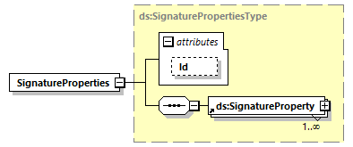
namespace | http://www.w3.org/2000/09/xmldsig#
type | ds:SignaturePropertiesType
properties
  content | complex
children | ds:SignatureProperty
attributes
  Name | Type | Use | Default | Fixed | Annotation
  Id | xs:ID | optional
source | <xs:element name="SignatureProperties" type="ds:SignaturePropertiesType"/>

element SignatureProperty
diagram | 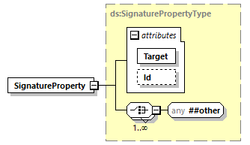
namespace | http://www.w3.org/2000/09/xmldsig#
type | ds:SignaturePropertyType
properties
  content | complex
  mixed | true
used by
  complexType | SignaturePropertiesType
attributes
  Name | Type | Use | Default | Fixed | Annotation
  Target | xs:anyURI | required
  Id | xs:ID | optional
source | <xs:element name="SignatureProperty" type="ds:SignaturePropertyType"/>

element SignatureValue
diagram | 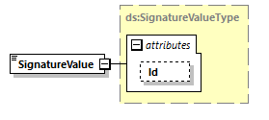
namespace | http://www.w3.org/2000/09/xmldsig#
type | ds:SignatureValueType
properties
  content | complex
used by
  complexType | SignatureType
attributes
  Name | Type | Use | Default | Fixed | Annotation
  Id | xs:ID | optional
source | <xs:element name="SignatureValue" type="ds:SignatureValueType"/>

element SignedInfo
diagram | 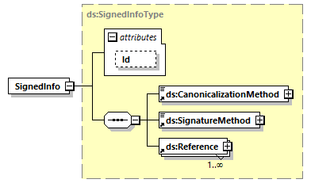
namespace | http://www.w3.org/2000/09/xmldsig#
type | ds:SignedInfoType
properties
  content | complex
children | ds:CanonicalizationMethod ds:SignatureMethod ds:Reference
used by
  complexType | SignatureType
attributes
  Name | Type | Use | Default | Fixed | Annotation
  Id | xs:ID | optional
source | <xs:element name="SignedInfo" type="ds:SignedInfoType"/>

element SPKIData
diagram | 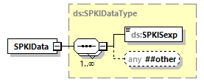
namespace | http://www.w3.org/2000/09/xmldsig#
type | ds:SPKIDataType
properties
  content | complex
children | ds:SPKISexp
used by
  complexType | KeyInfoType
source | <xs:element name="SPKIData" type="ds:SPKIDataType"/>

element Transform
diagram | 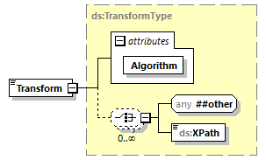
namespace | http://www.w3.org/2000/09/xmldsig#
type | ds:TransformType
properties
  content | complex
  mixed | true
children | ds:XPath
used by
  complexType | TransformsType
attributes
  Name | Type | Use | Default | Fixed | Annotation
  Algorithm | xs:anyURI | required
source | <xs:element name="Transform" type="ds:TransformType"/>

element Transforms
diagram | 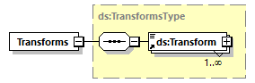
namespace | http://www.w3.org/2000/09/xmldsig#
type | ds:TransformsType
properties
  content | complex
children | ds:Transform
used by
  complexTypes | ReferenceType RetrievalMethodType
source | <xs:element name="Transforms" type="ds:TransformsType"/>

element X509Data
diagram | 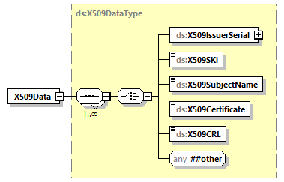
namespace | http://www.w3.org/2000/09/xmldsig#
type | ds:X509DataType
properties
  content | complex
children | ds:X509IssuerSerial ds:X509SKI ds:X509SubjectName ds:X509Certificate ds:X509CRL
used by
  complexType | KeyInfoType
source | <xs:element name="X509Data" type="ds:X509DataType"/>

complexType CanonicalizationMethodType
diagram | 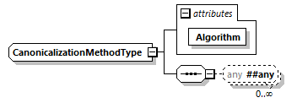
namespace | http://www.w3.org/2000/09/xmldsig#
properties
  mixed | true
used by
  element | CanonicalizationMethod
attributes
  Name | Type | Use | Default | Fixed | Annotation
  Algorithm | xs:anyURI | required
source | <xs:complexType name="CanonicalizationMethodType" mixed="true">  <xs:sequence>  <xs:any namespace="##any" minOccurs="0" maxOccurs="unbounded"/>  <!-- (0,unbounded) elements from (1,1) namespace -->  </xs:sequence>  <xs:attribute name="Algorithm" type="anyURI" use="required"/>  </xs:complexType>

attribute CanonicalizationMethodType/@Algorithm
type | xs:anyURI
properties
  use | required
source | <xs:attribute name="Algorithm" type="anyURI" use="required"/>

complexType DigestMethodType
diagram | 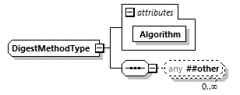
namespace | http://www.w3.org/2000/09/xmldsig#
properties
  mixed | true
used by
  element | DigestMethod
attributes
  Name | Type | Use | Default | Fixed | Annotation
  Algorithm | xs:anyURI | required
source | <xs:complexType name="DigestMethodType" mixed="true">  <xs:sequence>  <xs:any namespace="##other" processContents="lax" minOccurs="0" maxOccurs="unbounded"/>  </xs:sequence>  <xs:attribute name="Algorithm" type="anyURI" use="required"/>  </xs:complexType>

attribute DigestMethodType/@Algorithm
type | xs:anyURI
properties
  use | required
source | <xs:attribute name="Algorithm" type="anyURI" use="required"/>

complexType DSAKeyValueType
diagram | 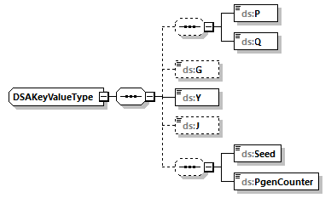
namespace | http://www.w3.org/2000/09/xmldsig#
children | ds:P ds:Q ds:G ds:Y ds:J ds:Seed ds:PgenCounter
used by
  element | DSAKeyValue
source | <xs:complexType name="DSAKeyValueType">  <xs:sequence>  <xs:sequence minOccurs="0">  <xs:element name="P" type="ds:CryptoBinary"/>  <xs:element name="Q" type="ds:CryptoBinary"/>  </xs:sequence>  <xs:element name="G" type="ds:CryptoBinary" minOccurs="0"/>  <xs:element name="Y" type="ds:CryptoBinary"/>  <xs:element name="J" type="ds:CryptoBinary" minOccurs="0"/>  <xs:sequence minOccurs="0">  <xs:element name="Seed" type="ds:CryptoBinary"/>  <xs:element name="PgenCounter" type="ds:CryptoBinary"/>  </xs:sequence>  </xs:sequence>  </xs:complexType>

element DSAKeyValueType/P
diagram | 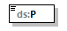
namespace | http://www.w3.org/2000/09/xmldsig#
type | ds:CryptoBinary
properties
  content | simple
source | <xs:element name="P" type="ds:CryptoBinary"/>

element DSAKeyValueType/Q
diagram | 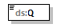
namespace | http://www.w3.org/2000/09/xmldsig#
type | ds:CryptoBinary
properties
  content | simple
source | <xs:element name="Q" type="ds:CryptoBinary"/>

element DSAKeyValueType/G
diagram | 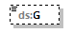
namespace | http://www.w3.org/2000/09/xmldsig#
type | ds:CryptoBinary
properties
  minOcc | 0
  maxOcc | 1
  content | simple
source | <xs:element name="G" type="ds:CryptoBinary" minOccurs="0"/>

element DSAKeyValueType/Y
diagram | 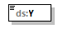
namespace | http://www.w3.org/2000/09/xmldsig#
type | ds:CryptoBinary
properties
  content | simple
source | <xs:element name="Y" type="ds:CryptoBinary"/>

element DSAKeyValueType/J
diagram | 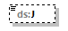
namespace | http://www.w3.org/2000/09/xmldsig#
type | ds:CryptoBinary
properties
  minOcc | 0
  maxOcc | 1
  content | simple
source | <xs:element name="J" type="ds:CryptoBinary" minOccurs="0"/>

element DSAKeyValueType/Seed
diagram | 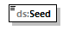
namespace | http://www.w3.org/2000/09/xmldsig#
type | ds:CryptoBinary
properties
  content | simple
source | <xs:element name="Seed" type="ds:CryptoBinary"/>

element DSAKeyValueType/PgenCounter
diagram | 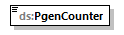
namespace | http://www.w3.org/2000/09/xmldsig#
type | ds:CryptoBinary
properties
  content | simple
source | <xs:element name="PgenCounter" type="ds:CryptoBinary"/>

complexType KeyInfoType
diagram | 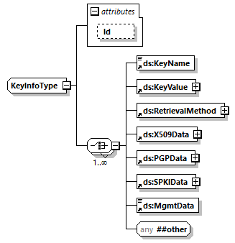
namespace | http://www.w3.org/2000/09/xmldsig#
properties
  mixed | true
children | ds:KeyName ds:KeyValue ds:RetrievalMethod ds:X509Data ds:PGPData ds:SPKIData ds:MgmtData
used by
  element | KeyInfo
attributes
  Name | Type | Use | Default | Fixed | Annotation
  Id | xs:ID | optional
source | <xs:complexType name="KeyInfoType" mixed="true">  <xs:choice maxOccurs="unbounded">  <xs:element ref="ds:KeyName"/>  <xs:element ref="ds:KeyValue"/>  <xs:element ref="ds:RetrievalMethod"/>  <xs:element ref="ds:X509Data"/>  <xs:element ref="ds:PGPData"/>  <xs:element ref="ds:SPKIData"/>  <xs:element ref="ds:MgmtData"/>  <xs:any namespace="##other" processContents="lax"/>  <!-- (1,1) elements from (0,unbounded) namespaces -->  </xs:choice>  <xs:attribute name="Id" type="ID" use="optional"/>  </xs:complexType>

attribute KeyInfoType/@Id
type | xs:ID
properties
  use | optional
source | <xs:attribute name="Id" type="ID" use="optional"/>

complexType KeyValueType
diagram | 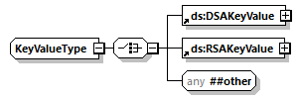
namespace | http://www.w3.org/2000/09/xmldsig#
properties
  mixed | true
children | ds:DSAKeyValue ds:RSAKeyValue
used by
  element | KeyValue
source | <xs:complexType name="KeyValueType" mixed="true">  <xs:choice>  <xs:element ref="ds:DSAKeyValue"/>  <xs:element ref="ds:RSAKeyValue"/>  <xs:any namespace="##other" processContents="lax"/>  </xs:choice>  </xs:complexType>

complexType ManifestType
diagram | 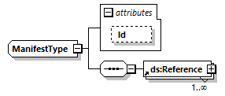
namespace | http://www.w3.org/2000/09/xmldsig#
children | ds:Reference
used by
  element | Manifest
attributes
  Name | Type | Use | Default | Fixed | Annotation
  Id | xs:ID | optional
source | <xs:complexType name="ManifestType">  <xs:sequence>  <xs:element ref="ds:Reference" maxOccurs="unbounded"/>  </xs:sequence>  <xs:attribute name="Id" type="ID" use="optional"/>  </xs:complexType>

attribute ManifestType/@Id
type | xs:ID
properties
  use | optional
source | <xs:attribute name="Id" type="ID" use="optional"/>

complexType ObjectType
diagram | 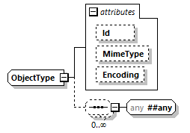
namespace | http://www.w3.org/2000/09/xmldsig#
properties
  mixed | true
used by
  element | Object
attributes
  Name | Type | Use | Default | Fixed | Annotation
  Id | xs:ID | optional
  MimeType | xs:string | optional
  Encoding | xs:anyURI | optional
source | <xs:complexType name="ObjectType" mixed="true">  <xs:sequence minOccurs="0" maxOccurs="unbounded">  <xs:any namespace="##any" processContents="lax"/>  </xs:sequence>  <xs:attribute name="Id" type="ID" use="optional"/>  <xs:attribute name="MimeType" type="string" use="optional"/>  <xs:attribute name="Encoding" type="anyURI" use="optional"/>  <!-- add a grep facet -->  </xs:complexType>

attribute ObjectType/@Id
type | xs:ID
properties
  use | optional
source | <xs:attribute name="Id" type="ID" use="optional"/>

attribute ObjectType/@MimeType
type | xs:string
properties
  use | optional
source | <xs:attribute name="MimeType" type="string" use="optional"/>

attribute ObjectType/@Encoding
type | xs:anyURI
properties
  use | optional
source | <xs:attribute name="Encoding" type="anyURI" use="optional"/>

complexType PGPDataType
diagram | 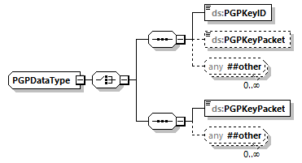
namespace | http://www.w3.org/2000/09/xmldsig#
children | ds:PGPKeyID ds:PGPKeyPacket ds:PGPKeyPacket
used by
  element | PGPData
source | <xs:complexType name="PGPDataType">  <xs:choice>  <xs:sequence>  <xs:element name="PGPKeyID" type="base64Binary"/>  <xs:element name="PGPKeyPacket" type="base64Binary" minOccurs="0"/>  <xs:any namespace="##other" processContents="lax" minOccurs="0" maxOccurs="unbounded"/>  </xs:sequence>  <xs:sequence>  <xs:element name="PGPKeyPacket" type="base64Binary"/>  <xs:any namespace="##other" processContents="lax" minOccurs="0" maxOccurs="unbounded"/>  </xs:sequence>  </xs:choice>  </xs:complexType>

element PGPDataType/PGPKeyID
diagram | 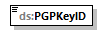
namespace | http://www.w3.org/2000/09/xmldsig#
type | xs:base64Binary
properties
  content | simple
source | <xs:element name="PGPKeyID" type="base64Binary"/>

element PGPDataType/PGPKeyPacket
diagram | 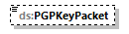
namespace | http://www.w3.org/2000/09/xmldsig#
type | xs:base64Binary
properties
  minOcc | 0
  maxOcc | 1
  content | simple
source | <xs:element name="PGPKeyPacket" type="base64Binary" minOccurs="0"/>

element PGPDataType/PGPKeyPacket
diagram | 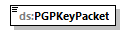
namespace | http://www.w3.org/2000/09/xmldsig#
type | xs:base64Binary
properties
  content | simple
source | <xs:element name="PGPKeyPacket" type="base64Binary"/>

complexType ReferenceType
diagram | 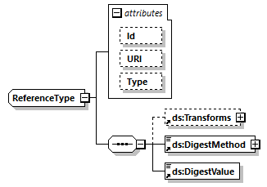
namespace | http://www.w3.org/2000/09/xmldsig#
children | ds:Transforms ds:DigestMethod ds:DigestValue
used by
  element | Reference
attributes
  Name | Type | Use | Default | Fixed | Annotation
  Id | xs:ID | optional
  URI | xs:anyURI | optional
  Type | xs:anyURI | optional
source | <xs:complexType name="ReferenceType">  <xs:sequence>  <xs:element ref="ds:Transforms" minOccurs="0"/>  <xs:element ref="ds:DigestMethod"/>  <xs:element ref="ds:DigestValue"/>  </xs:sequence>  <xs:attribute name="Id" type="ID" use="optional"/>  <xs:attribute name="URI" type="anyURI" use="optional"/>  <xs:attribute name="Type" type="anyURI" use="optional"/>  </xs:complexType>

attribute ReferenceType/@Id
type | xs:ID
properties
  use | optional
source | <xs:attribute name="Id" type="ID" use="optional"/>

attribute ReferenceType/@URI
type | xs:anyURI
properties
  use | optional
source | <xs:attribute name="URI" type="anyURI" use="optional"/>

attribute ReferenceType/@Type
type | xs:anyURI
properties
  use | optional
source | <xs:attribute name="Type" type="anyURI" use="optional"/>

complexType RetrievalMethodType
diagram | 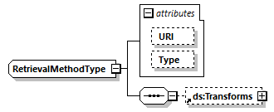
namespace | http://www.w3.org/2000/09/xmldsig#
children | ds:Transforms
used by
  element | RetrievalMethod
attributes
  Name | Type | Use | Default | Fixed | Annotation
  URI | xs:anyURI
  Type | xs:anyURI | optional
source | <xs:complexType name="RetrievalMethodType">  <xs:sequence>  <xs:element ref="ds:Transforms" minOccurs="0"/>  </xs:sequence>  <xs:attribute name="URI" type="anyURI"/>  <xs:attribute name="Type" type="anyURI" use="optional"/>  </xs:complexType>

attribute RetrievalMethodType/@URI
type | xs:anyURI
source | <xs:attribute name="URI" type="anyURI"/>

attribute RetrievalMethodType/@Type
type | xs:anyURI
properties
  use | optional
source | <xs:attribute name="Type" type="anyURI" use="optional"/>

complexType RSAKeyValueType
diagram | 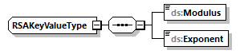
namespace | http://www.w3.org/2000/09/xmldsig#
children | ds:Modulus ds:Exponent
used by
  element | RSAKeyValue
source | <xs:complexType name="RSAKeyValueType">  <xs:sequence>  <xs:element name="Modulus" type="ds:CryptoBinary"/>  <xs:element name="Exponent" type="ds:CryptoBinary"/>  </xs:sequence>  </xs:complexType>

element RSAKeyValueType/Modulus
diagram | 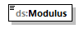
namespace | http://www.w3.org/2000/09/xmldsig#
type | ds:CryptoBinary
properties
  content | simple
source | <xs:element name="Modulus" type="ds:CryptoBinary"/>

element RSAKeyValueType/Exponent
diagram | 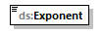
namespace | http://www.w3.org/2000/09/xmldsig#
type | ds:CryptoBinary
properties
  content | simple
source | <xs:element name="Exponent" type="ds:CryptoBinary"/>

complexType SignatureMethodType
diagram | 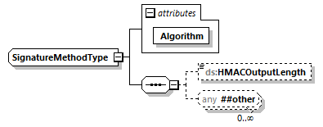
namespace | http://www.w3.org/2000/09/xmldsig#
properties
  mixed | true
children | ds:HMACOutputLength
used by
  element | SignatureMethod
attributes
  Name | Type | Use | Default | Fixed | Annotation
  Algorithm | xs:anyURI | required
source | <xs:complexType name="SignatureMethodType" mixed="true">  <xs:sequence>  <xs:element name="HMACOutputLength" type="ds:HMACOutputLengthType" minOccurs="0"/>  <xs:any namespace="##other" minOccurs="0" maxOccurs="unbounded"/>  <!-- (0,unbounded) elements from (1,1) external namespace -->  </xs:sequence>  <xs:attribute name="Algorithm" type="anyURI" use="required"/>  </xs:complexType>

attribute SignatureMethodType/@Algorithm
type | xs:anyURI
properties
  use | required
source | <xs:attribute name="Algorithm" type="anyURI" use="required"/>

element SignatureMethodType/HMACOutputLength
diagram | 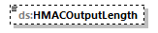
namespace | http://www.w3.org/2000/09/xmldsig#
type | ds:HMACOutputLengthType
properties
  minOcc | 0
  maxOcc | 1
  content | simple
source | <xs:element name="HMACOutputLength" type="ds:HMACOutputLengthType" minOccurs="0"/>

complexType SignaturePropertiesType
diagram | 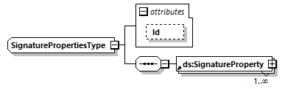
namespace | http://www.w3.org/2000/09/xmldsig#
children | ds:SignatureProperty
used by
  element | SignatureProperties
attributes
  Name | Type | Use | Default | Fixed | Annotation
  Id | xs:ID | optional
source | <xs:complexType name="SignaturePropertiesType">  <xs:sequence>  <xs:element ref="ds:SignatureProperty" maxOccurs="unbounded"/>  </xs:sequence>  <xs:attribute name="Id" type="ID" use="optional"/>  </xs:complexType>

attribute SignaturePropertiesType/@Id
type | xs:ID
properties
  use | optional
source | <xs:attribute name="Id" type="ID" use="optional"/>

complexType SignaturePropertyType
diagram | 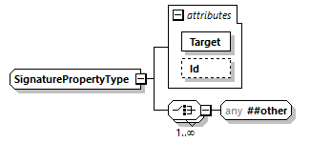
namespace | http://www.w3.org/2000/09/xmldsig#
properties
  mixed | true
used by
  element | SignatureProperty
attributes
  Name | Type | Use | Default | Fixed | Annotation
  Target | xs:anyURI | required
  Id | xs:ID | optional
source | <xs:complexType name="SignaturePropertyType" mixed="true">  <xs:choice maxOccurs="unbounded">  <xs:any namespace="##other" processContents="lax"/>  <!-- (1,1) elements from (1,unbounded) namespaces -->  </xs:choice>  <xs:attribute name="Target" type="anyURI" use="required"/>  <xs:attribute name="Id" type="ID" use="optional"/>  </xs:complexType>

attribute SignaturePropertyType/@Target
type | xs:anyURI
properties
  use | required
source | <xs:attribute name="Target" type="anyURI" use="required"/>

attribute SignaturePropertyType/@Id
type | xs:ID
properties
  use | optional
source | <xs:attribute name="Id" type="ID" use="optional"/>

complexType SignatureType
diagram | 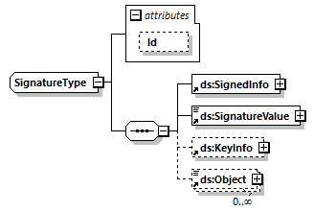
namespace | http://www.w3.org/2000/09/xmldsig#
children | ds:SignedInfo ds:SignatureValue ds:KeyInfo ds:Object
used by
  element | Signature
attributes
  Name | Type | Use | Default | Fixed | Annotation
  Id | xs:ID | optional
source | <xs:complexType name="SignatureType">  <xs:sequence>  <xs:element ref="ds:SignedInfo"/>  <xs:element ref="ds:SignatureValue"/>  <xs:element ref="ds:KeyInfo" minOccurs="0"/>  <xs:element ref="ds:Object" minOccurs="0" maxOccurs="unbounded"/>  </xs:sequence>  <xs:attribute name="Id" type="ID" use="optional"/>  </xs:complexType>

attribute SignatureType/@Id
type | xs:ID
properties
  use | optional
source | <xs:attribute name="Id" type="ID" use="optional"/>

complexType SignatureValueType
diagram | 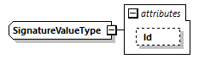
namespace | http://www.w3.org/2000/09/xmldsig#
type | extension of xs:base64Binary
properties
  base | base64Binary
used by
  element | SignatureValue
attributes
  Name | Type | Use | Default | Fixed | Annotation
  Id | xs:ID | optional
source | <xs:complexType name="SignatureValueType">  <xs:simpleContent>  <xs:extension base="base64Binary">  <xs:attribute name="Id" type="ID" use="optional"/>  </xs:extension>  </xs:simpleContent>  </xs:complexType>

attribute SignatureValueType/@Id
type | xs:ID
properties
  use | optional
source | <xs:attribute name="Id" type="ID" use="optional"/>

complexType SignedInfoType
diagram | 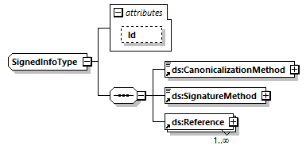
namespace | http://www.w3.org/2000/09/xmldsig#
children | ds:CanonicalizationMethod ds:SignatureMethod ds:Reference
used by
  element | SignedInfo
attributes
  Name | Type | Use | Default | Fixed | Annotation
  Id | xs:ID | optional
source | <xs:complexType name="SignedInfoType">  <xs:sequence>  <xs:element ref="ds:CanonicalizationMethod"/>  <xs:element ref="ds:SignatureMethod"/>  <xs:element ref="ds:Reference" maxOccurs="unbounded"/>  </xs:sequence>  <xs:attribute name="Id" type="ID" use="optional"/>  </xs:complexType>

attribute SignedInfoType/@Id
type | xs:ID
properties
  use | optional
source | <xs:attribute name="Id" type="ID" use="optional"/>

complexType SPKIDataType
diagram | 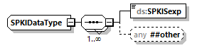
namespace | http://www.w3.org/2000/09/xmldsig#
children | ds:SPKISexp
used by
  element | SPKIData
source | <xs:complexType name="SPKIDataType">  <xs:sequence maxOccurs="unbounded">  <xs:element name="SPKISexp" type="base64Binary"/>  <xs:any namespace="##other" processContents="lax" minOccurs="0"/>  </xs:sequence>  </xs:complexType>

element SPKIDataType/SPKISexp
diagram | 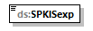
namespace | http://www.w3.org/2000/09/xmldsig#
type | xs:base64Binary
properties
  content | simple
source | <xs:element name="SPKISexp" type="base64Binary"/>

complexType TransformsType
diagram | 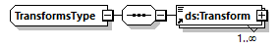
namespace | http://www.w3.org/2000/09/xmldsig#
children | ds:Transform
used by
  element | Transforms
source | <xs:complexType name="TransformsType">  <xs:sequence>  <xs:element ref="ds:Transform" maxOccurs="unbounded"/>  </xs:sequence>  </xs:complexType>

complexType TransformType
diagram | 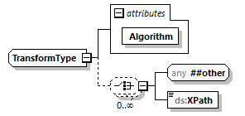
namespace | http://www.w3.org/2000/09/xmldsig#
properties
  mixed | true
children | ds:XPath
used by
  element | Transform
attributes
  Name | Type | Use | Default | Fixed | Annotation
  Algorithm | xs:anyURI | required
source | <xs:complexType name="TransformType" mixed="true">  <xs:choice minOccurs="0" maxOccurs="unbounded">  <xs:any namespace="##other" processContents="lax"/>  <!-- (1,1) elements from (0,unbounded) namespaces -->  <xs:element name="XPath" type="string"/>  </xs:choice>  <xs:attribute name="Algorithm" type="anyURI" use="required"/>  </xs:complexType>

attribute TransformType/@Algorithm
type | xs:anyURI
properties
  use | required
source | <xs:attribute name="Algorithm" type="anyURI" use="required"/>

element TransformType/XPath
diagram | 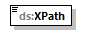
namespace | http://www.w3.org/2000/09/xmldsig#
type | xs:string
properties
  content | simple
source | <xs:element name="XPath" type="string"/>

complexType X509DataType
diagram | 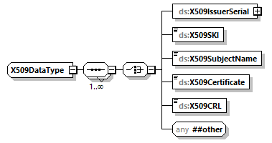
namespace | http://www.w3.org/2000/09/xmldsig#
children | ds:X509IssuerSerial ds:X509SKI ds:X509SubjectName ds:X509Certificate ds:X509CRL
used by
  element | X509Data
source | <xs:complexType name="X509DataType">  <xs:sequence maxOccurs="unbounded">  <xs:choice>  <xs:element name="X509IssuerSerial" type="ds:X509IssuerSerialType"/>  <xs:element name="X509SKI" type="base64Binary"/>  <xs:element name="X509SubjectName" type="string"/>  <xs:element name="X509Certificate" type="base64Binary"/>  <xs:element name="X509CRL" type="base64Binary"/>  <xs:any namespace="##other" processContents="lax"/>  </xs:choice>  </xs:sequence>  </xs:complexType>

element X509DataType/X509IssuerSerial
diagram | 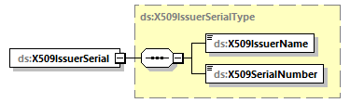
namespace | http://www.w3.org/2000/09/xmldsig#
type | ds:X509IssuerSerialType
properties
  content | complex
children | ds:X509IssuerName ds:X509SerialNumber
source | <xs:element name="X509IssuerSerial" type="ds:X509IssuerSerialType"/>

element X509DataType/X509SKI
diagram | 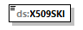
namespace | http://www.w3.org/2000/09/xmldsig#
type | xs:base64Binary
properties
  content | simple
source | <xs:element name="X509SKI" type="base64Binary"/>

element X509DataType/X509SubjectName
diagram | 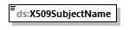
namespace | http://www.w3.org/2000/09/xmldsig#
type | xs:string
properties
  content | simple
source | <xs:element name="X509SubjectName" type="string"/>

element X509DataType/X509Certificate
diagram | 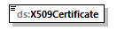
namespace | http://www.w3.org/2000/09/xmldsig#
type | xs:base64Binary
properties
  content | simple
source | <xs:element name="X509Certificate" type="base64Binary"/>

element X509DataType/X509CRL
diagram | 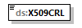
namespace | http://www.w3.org/2000/09/xmldsig#
type | xs:base64Binary
properties
  content | simple
source | <xs:element name="X509CRL" type="base64Binary"/>

complexType X509IssuerSerialType
diagram | 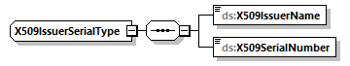
namespace | http://www.w3.org/2000/09/xmldsig#
children | ds:X509IssuerName ds:X509SerialNumber
used by
  element | X509DataType/X509IssuerSerial
source | <xs:complexType name="X509IssuerSerialType">  <xs:sequence>  <xs:element name="X509IssuerName" type="string"/>  <xs:element name="X509SerialNumber" type="integer"/>  </xs:sequence>  </xs:complexType>

element X509IssuerSerialType/X509IssuerName
diagram | 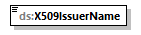
namespace | http://www.w3.org/2000/09/xmldsig#
type | xs:string
properties
  content | simple
source | <xs:element name="X509IssuerName" type="string"/>

element X509IssuerSerialType/X509SerialNumber
diagram | 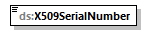
namespace | http://www.w3.org/2000/09/xmldsig#
type | xs:integer
properties
  content | simple
source | <xs:element name="X509SerialNumber" type="integer"/>

simpleType CryptoBinary
namespace | http://www.w3.org/2000/09/xmldsig#
type | xs:base64Binary
properties
  base | base64Binary
used by
  elements | RSAKeyValueType/Exponent DSAKeyValueType/G DSAKeyValueType/J RSAKeyValueType/Modulus DSAKeyValueType/P DSAKeyValueType/PgenCounter DSAKeyValueType/Q DSAKeyValueType/Seed DSAKeyValueType/Y
source | <xs:simpleType name="CryptoBinary">  <xs:restriction base="base64Binary"/>  </xs:simpleType>

simpleType DigestValueType
namespace | http://www.w3.org/2000/09/xmldsig#
type | xs:base64Binary
properties
  base | base64Binary
used by
  element | DigestValue
source | <xs:simpleType name="DigestValueType">  <xs:restriction base="base64Binary"/>  </xs:simpleType>

simpleType HMACOutputLengthType
namespace | http://www.w3.org/2000/09/xmldsig#
type | xs:integer
properties
  base | integer
used by
  element | SignatureMethodType/HMACOutputLength
source | <xs:simpleType name="HMACOutputLengthType">  <xs:restriction base="integer"/>  </xs:simpleType>

XML Schema documentation generated by XMLSpy Schema Editor http://www.altova.com/xmlspy

